CSC 35

Ryan Farruggia

Professor Ghansah

18 February 2021

Lab Report #2

Image of source code (1/2) before debugging

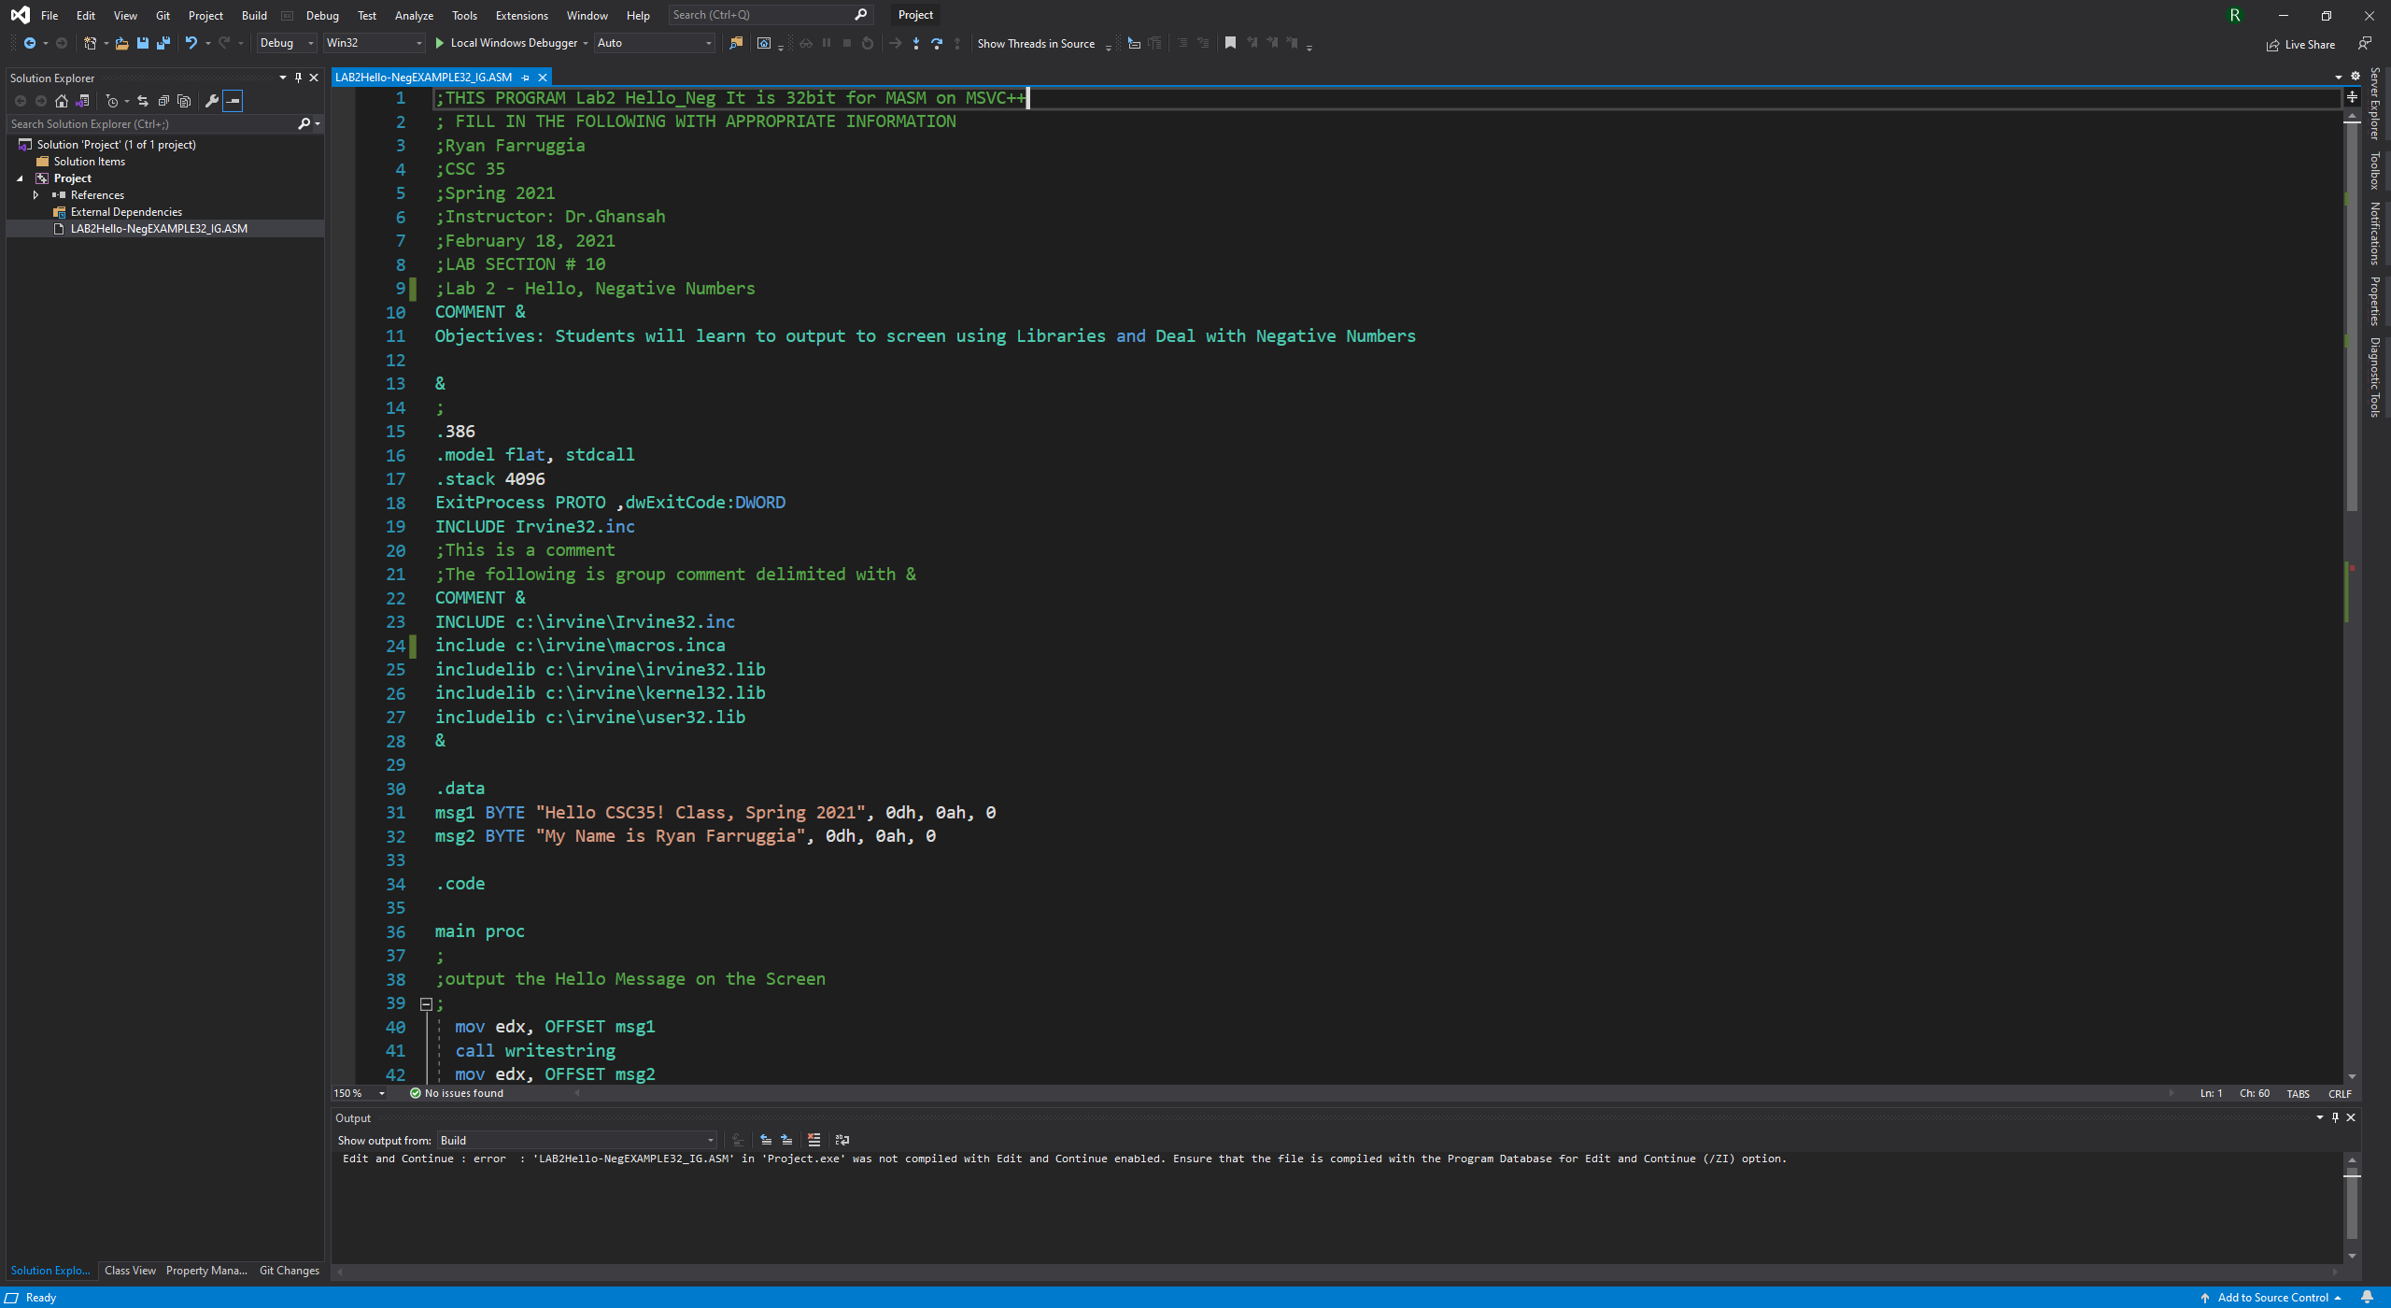

Image of source code (2/2) before debugging

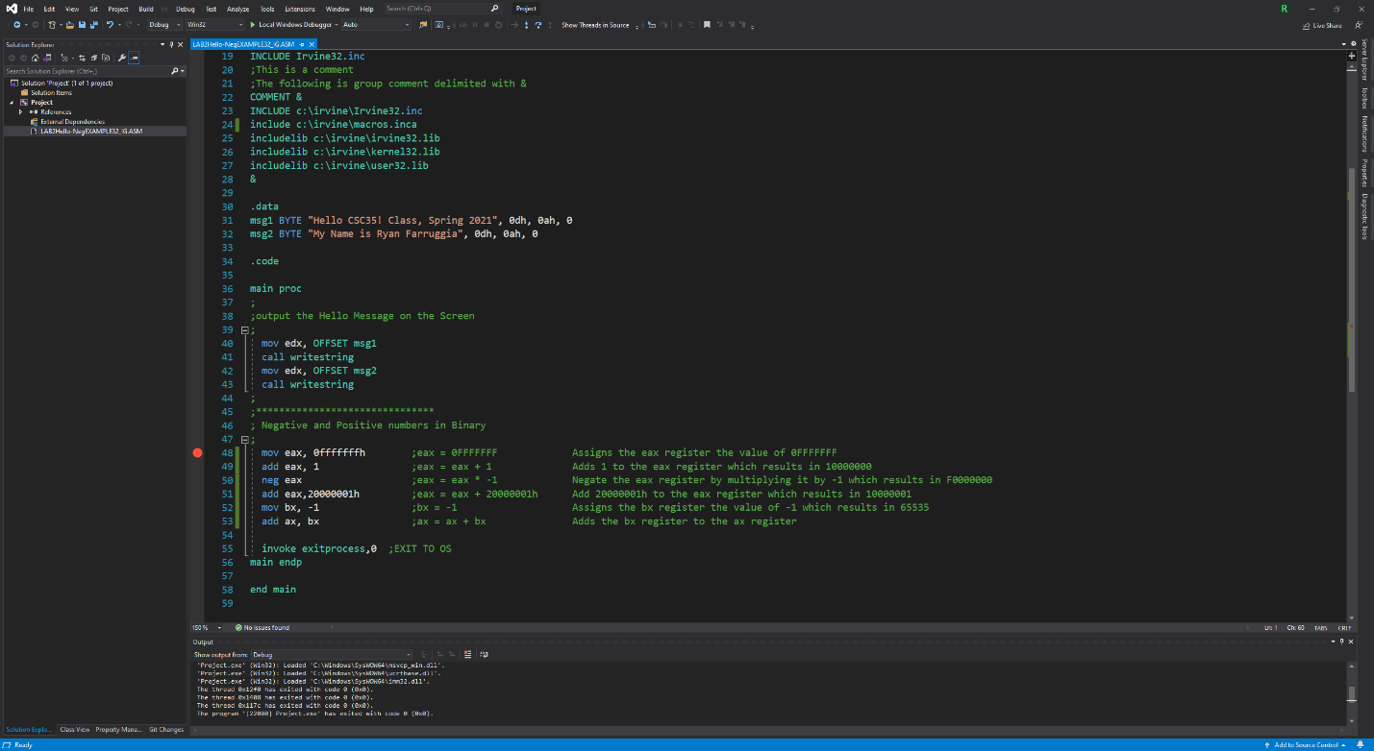

Image of console displaying the “Hello” portion of the lab during debugging

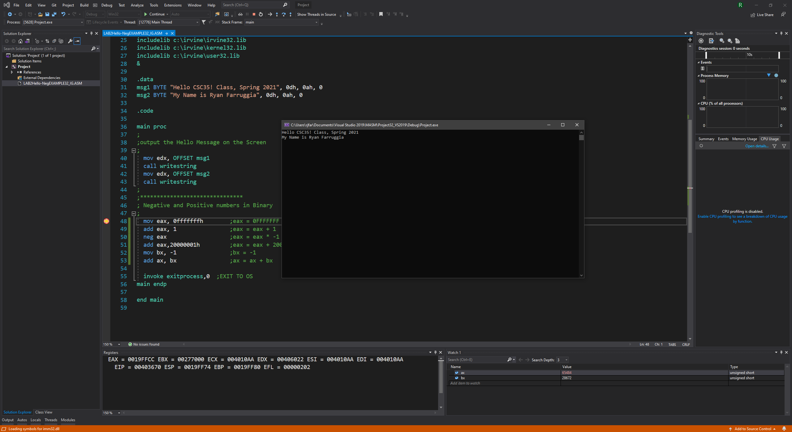

Breakpoint where the “Negative and Positive” numbers portion begins (with register values)

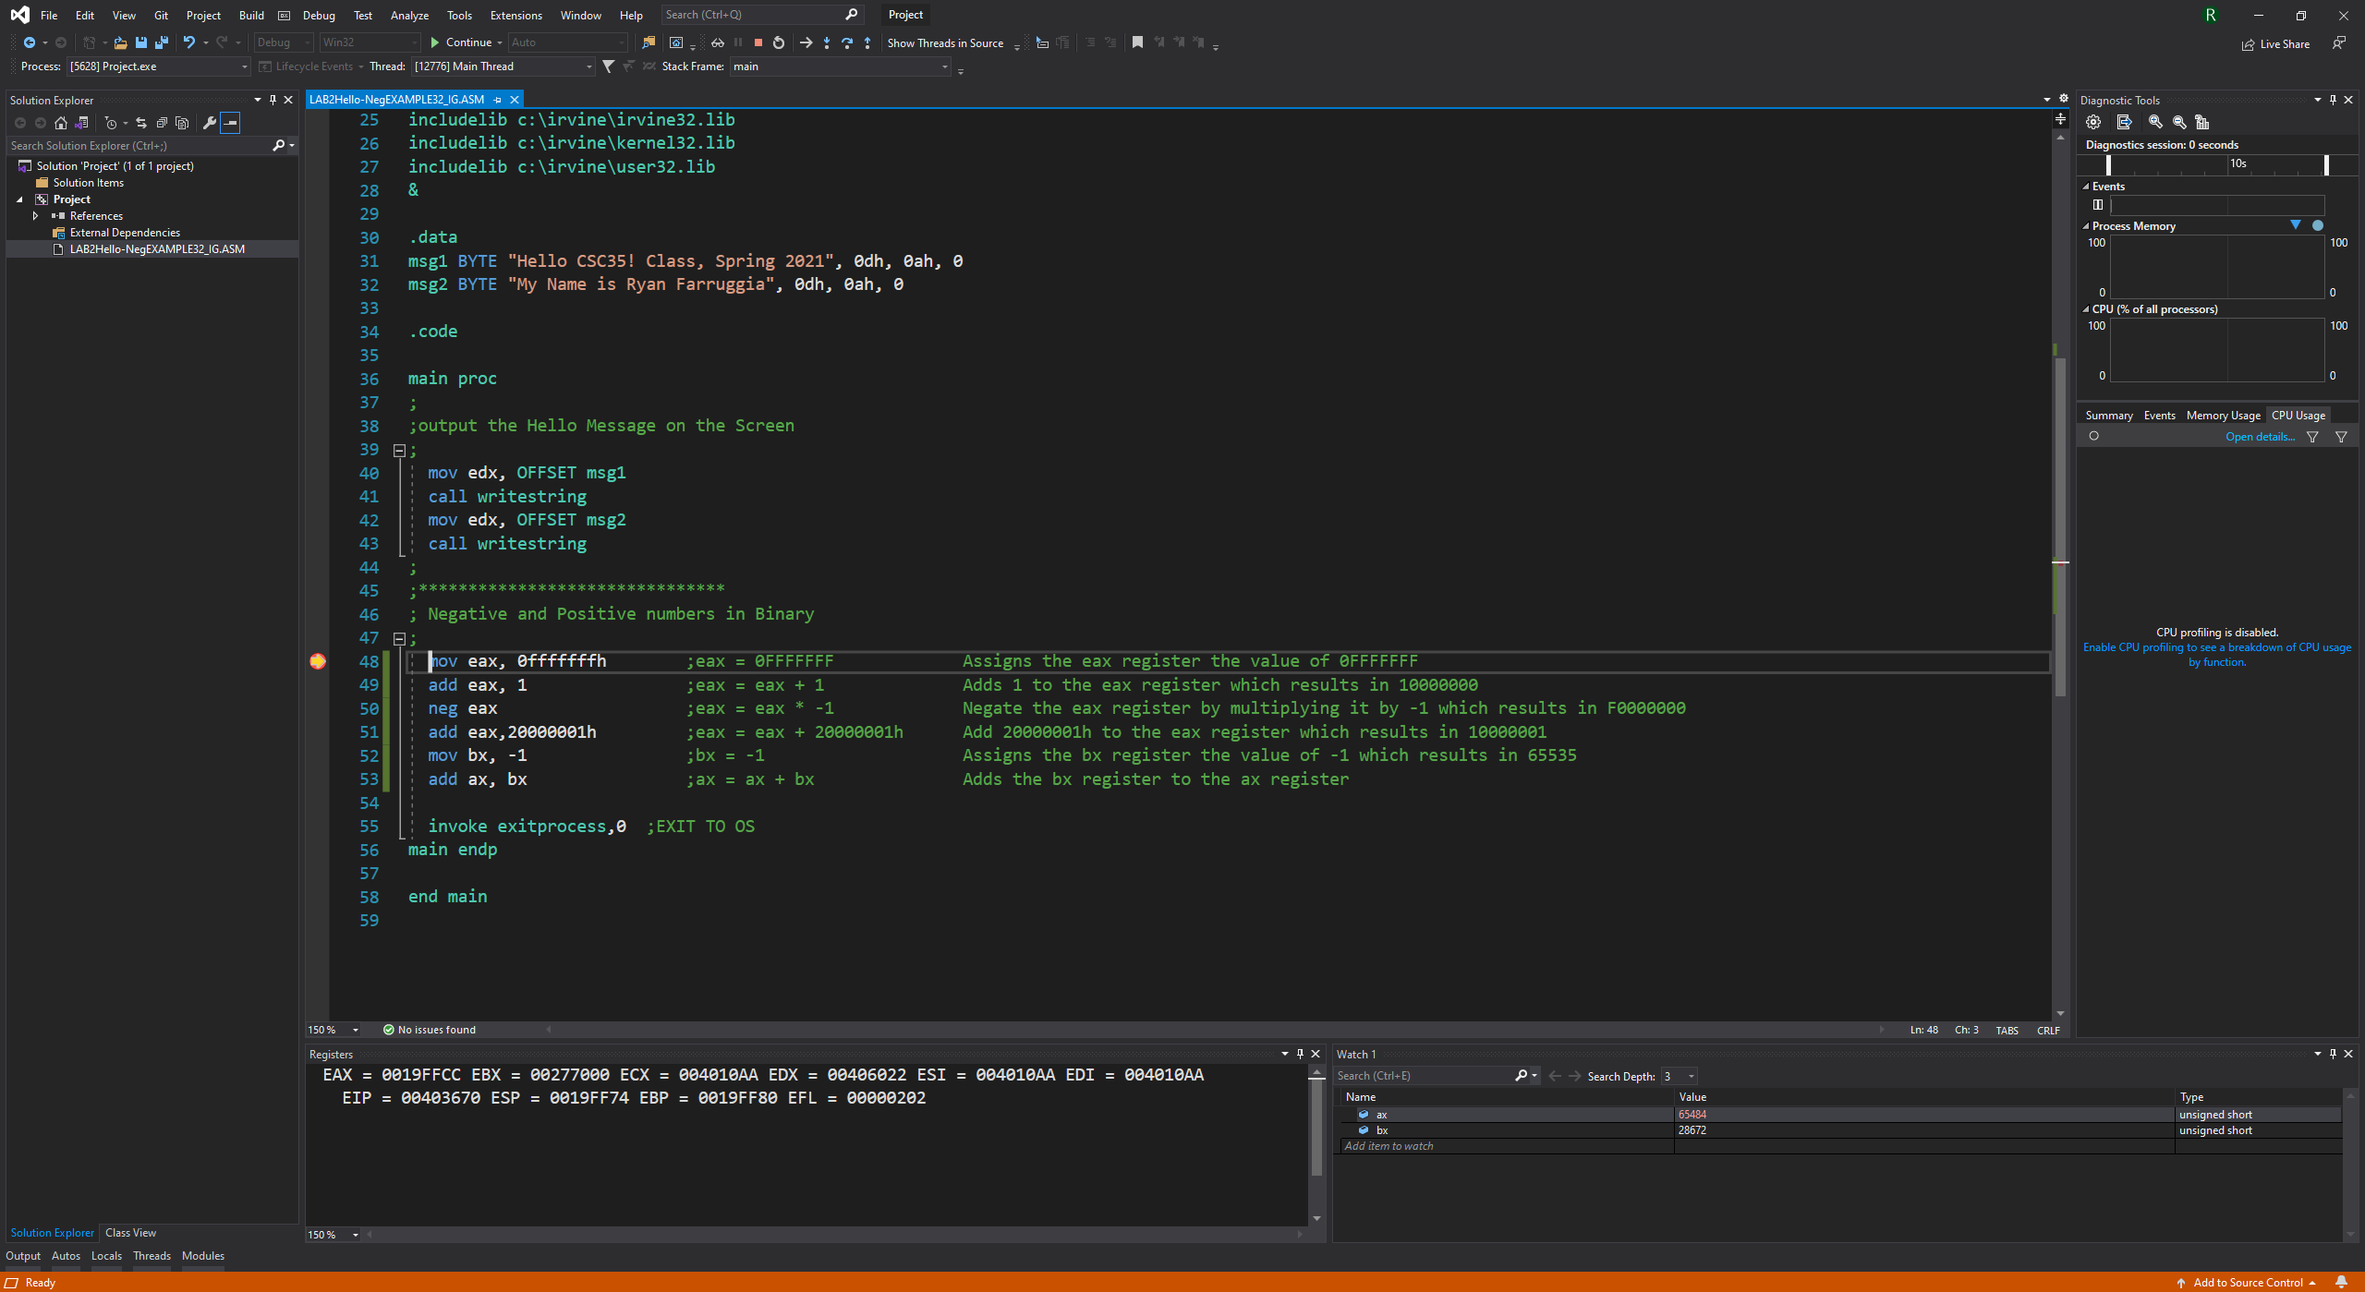

Debugging line 48 (mov eax, 0fffffffh) with register values shown

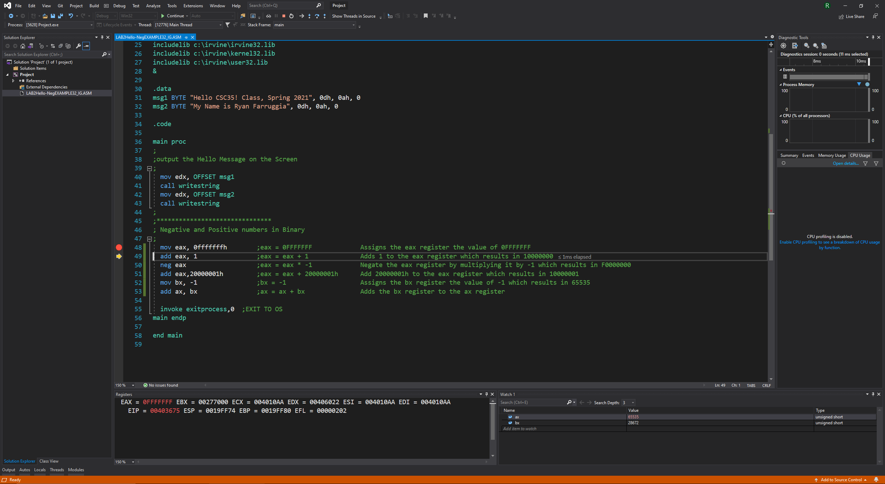

Debugging line 49 (add eax, 1) with register values shown

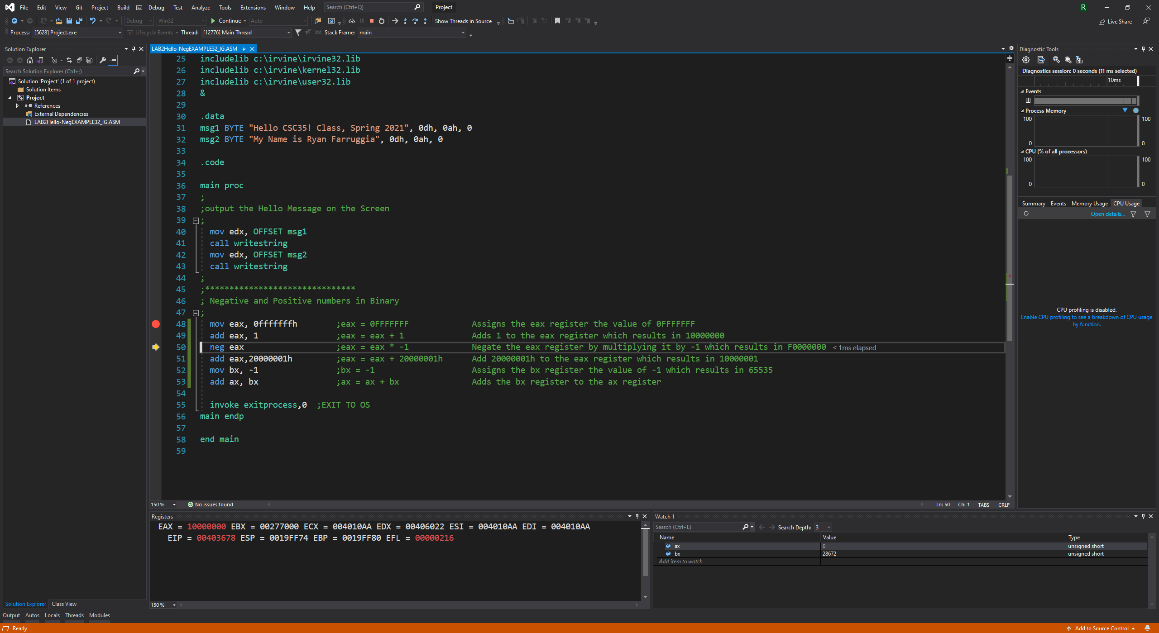

Debugging line 50 (neg eax) with register values shown

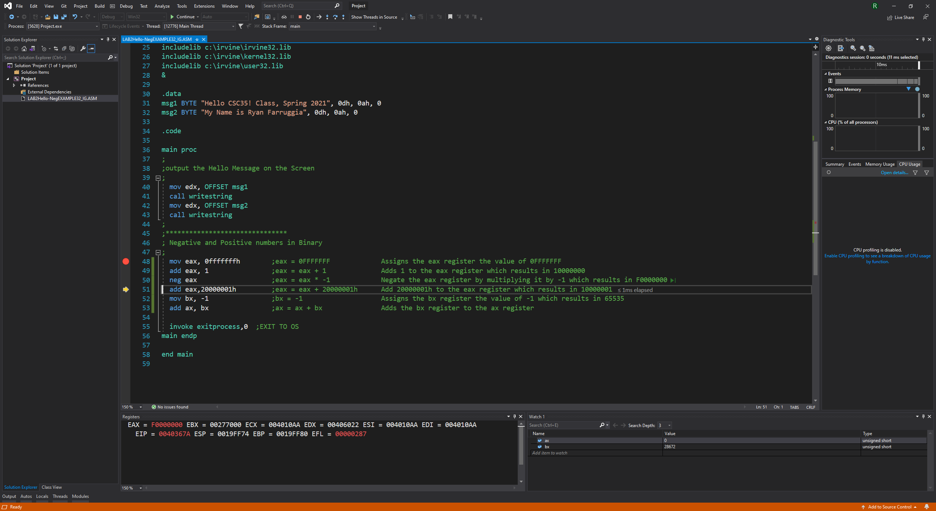

Debugging line 51 (add eax, 20000001h) with register values shown

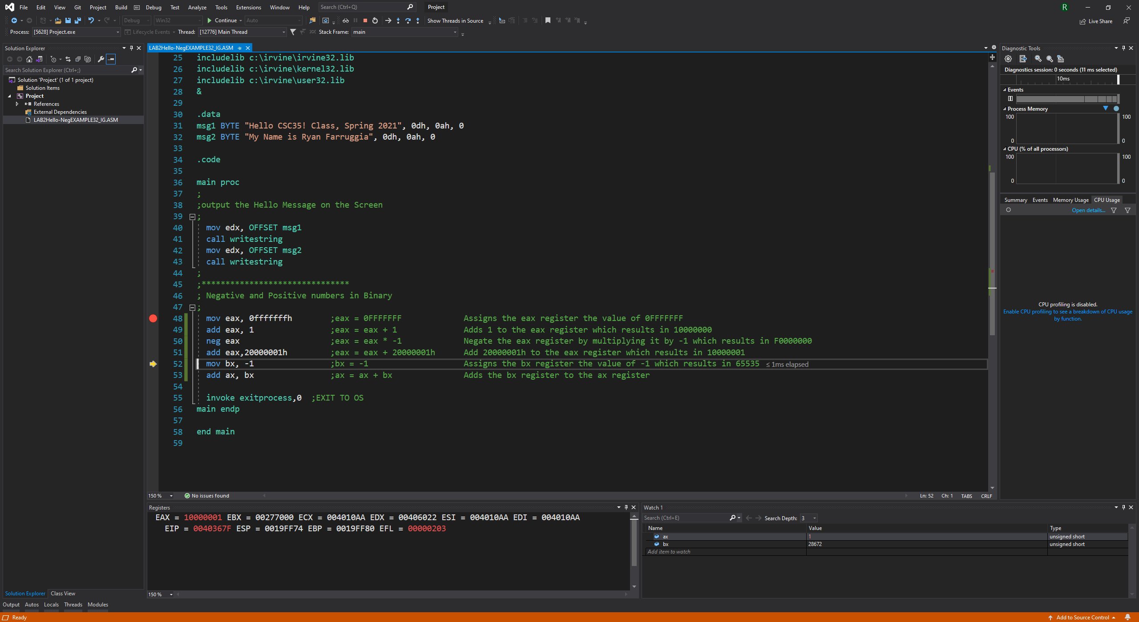

Debugging line 52 (mov bx, -1) with register values shown

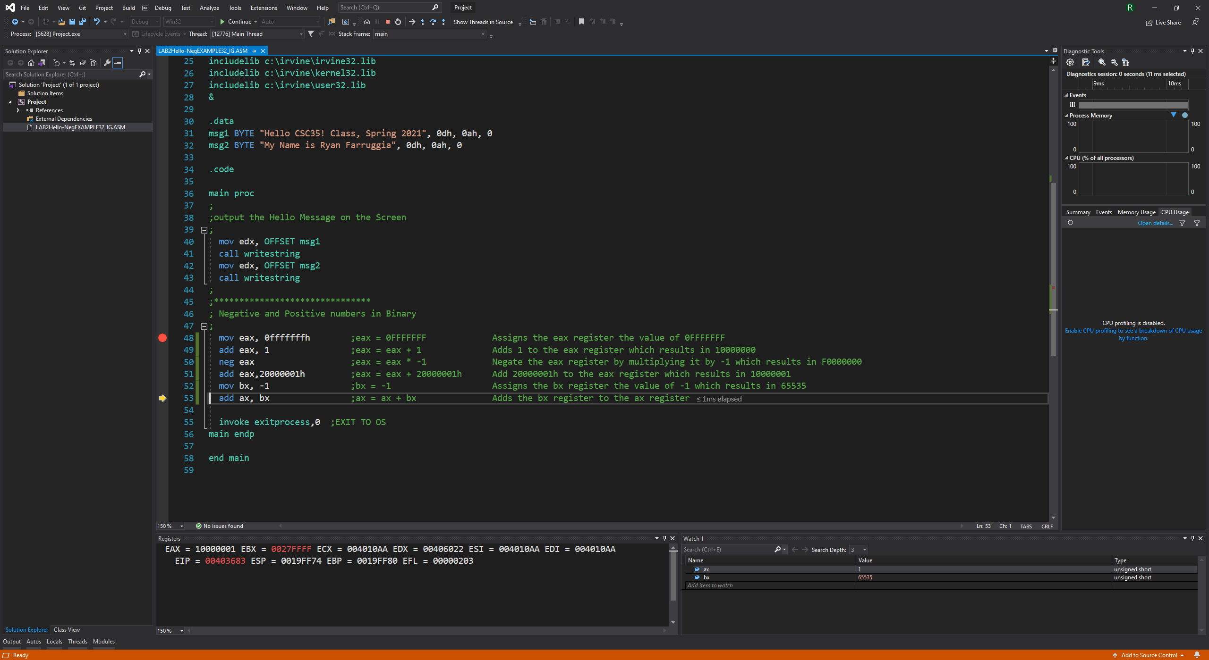

Debugging line 53 (add ax, bx) with register values shown

